ARTICLE ON REST API

REST (Representation State Transfer) is the architectural model that makes communication easier between the two system i.e. wed/application and server system. REST often called RESTfull API system. Now let’s understand about REST API system. REST API is the set of rules that developer must follow when developing system. REST API is the most commonly used method for developing an API.

Now in this section we will learn about some advantages of REST API. The main advantages of REST API is separation of client and server. The implementation of server and implementation of client is independent so that each of the system does not know about each other. The change of code in the sever system does not affect the operations of client system and vice versa. It is easy to learn and it is flexible to work with REST API. They can work with XHTML, JSON which is a lighted file. They work with all type of integer. They have fast speed and reliable.

The drawbacks of REST API are as follows. It is difficult to learn for beginners developer. One must have understand to make an REST API a RESTFUL API. Authentication compromise is another drawbacks of REST API . Because to access to some resource user should have permission to access. It is also time consuming and hard to parse the JSON format data.

REST API testing tools means is the software that test the API (Application Program Interface fulfills the expected reliability, functionality, performance, security and validity. The most widely used REST API testing tools are: UI Soap, Postman, Jmeter, etc.

API Documentation tools helps to create API and provides information they need to successfully work with API. Some of the API Documentation tools are: Postman, Swagger Hub, OpenAI Generator. They helps to manage and create the API Documentation.

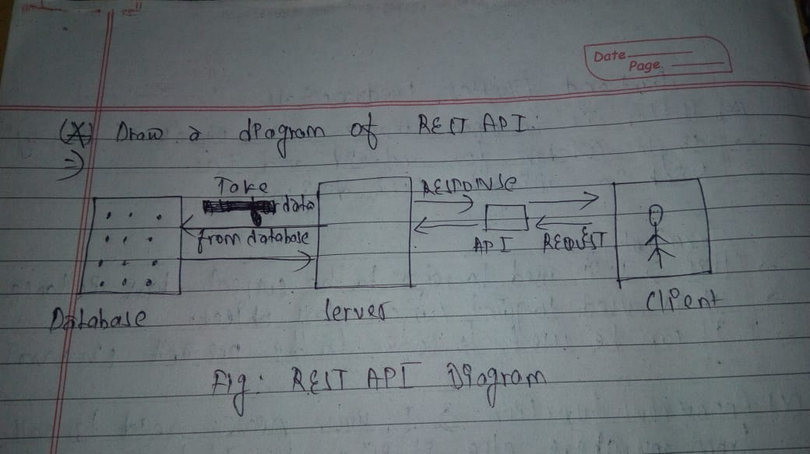

Fig : Representation of REST API includes Client Server and the data transmission.

Written and Created By: Prabin Bhattarai

Bsc.CSIT 3rd Semester

.